French Home Study Plan – Year 11
Week | Date | Activity | Homework Overview
1A | 1-Sep | No Homework | 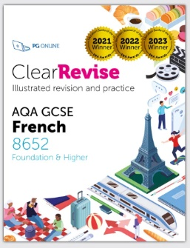  - Complete these pages in your Clear Revise AQA GCSE French Book. Make sure you learn key vocabulary.    - **Each week there will also be a Languagenut assignment.  www.languagenut.com  (Log-in with Office 365)  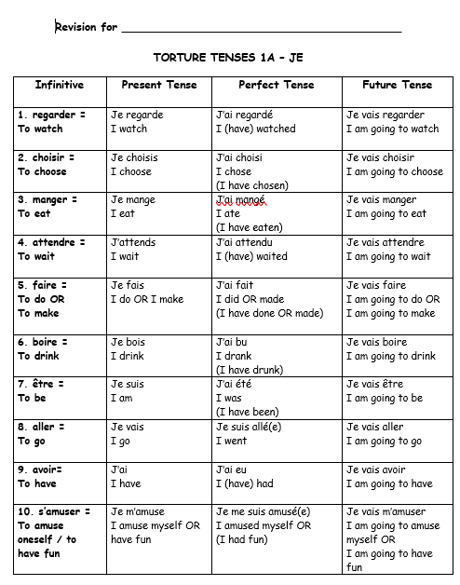  - Students will also be asked to learn Torture Tenses & learn answers to Speaking Questions.
2B | 8-Sep | Topic 5: Customs, Festivals & Celebrations  Celebrations P62-63  & Languagenut Assignment
3A | 15-Sep | Festivals around the world & Special Days P64-67  Weddings & Christmas Time P68-71  & Languagenut Assignment
4B | 22-Sep | Topic 6: Celebrity Culture  Celebrities P74-75  & Languagenut Assignment
5A | 29-Sep | Reality TV P76-77  & Languagenut Assignment
6B | 6-Oct | Celebrities as Role Models P78-79  Languagenut Assignment &  *Speaking Mock Exam Revision
7A | 13-Oct | Influencers P80-81  & Languagenut Assignment
8B | 20-Oct | Pros & Cons of Fame P82-83  & Languagenut Assignment
***October Half term***
9A | 3-Nov | Putting it all together – Celebrity Culture  & Languagenut Assignment
10B | 10-Nov | Theme 2 Popular Culture Exam Practice P87-90  & Languagenut Assignment
11A | 17-Nov | Topic 7: Travel & Tourism  Transportation P92-93  & Languagenut Assignment
12B | 24-Nov | The Weather P94-95  & Languagenut Assignment
13A | 1-Dec | School Holidays P96-97  & Languagenut Assignment
14B | 8-Dec | Holidays P98-99  & Languagenut Assignment
15A | 15-Dec | Places of Interest P100-101  & Languagenut Assignment
***Christmas***
16B | 5-Jan | Putting it all together – Travel & Tourism  P102-103 & Languagenut Assignment
17A | 12-Jan | Topic 8: Media & Technology  Using a Smartphone P104-105  & Languagenut Assignment
18B | 19-Jan | The internet P106-107  Languagenut Assignment &  *Speaking Mock Exam Revision
19A | 26-Jan | Social Media P108-109  & Languagenut Assignment
20B | 2-Feb | Technology Problems P110-111  & Languagenut Assignment
21A | 9-Feb | Putting it all together – Media & Technology & Languagenut Assignment
***February Half term***
22B | 23-Feb | Topic 9: The Environment  Where people Live P116-117  & Languagenut Assignment
23A | 2-Mar | Towns & Cities P118-119  & Languagenut Assignment
24B | 9-Mar | Describing the area P120-121  & Languagenut Assignment
25A | 16-Mar | The Environment P122-123  & Languagenut Assignment
26B | 23-Mar | The Planet P124-125  & Languagenut Assignment
***Easter***GCSE Speaking Exam Revision
27A | 13-Apr | Putting it all together –The Environment & Where people Live P126-127  Languagenut Assignment &  *GCSE Speaking Exam Revision
28B | 20-Apr | Examination Practice P129-132  & Languagenut Assignment
29A | 27-Apr | Languagenut Assignment
30B | 4-May | Languagenut Assignment  AQA Mock Foundation or Higher Tier  Listening French
31A | 11-May | Languagenut Assignment  AQA Mock Foundation or Higher Tier  Reading French
32B | 18-May | Listening & Reading Exam Revision for  20th May AM  Languagenut Assignment  AQA Mock Foundation or Higher Tier  Writing French
***May Half term***
33A | 1-June | Writing Exam Revision for  4th June PM

