French Home Study Plan – Year 10
Week | Date | Activity | Homework Overview
1A | 1-Sep | No Homework | 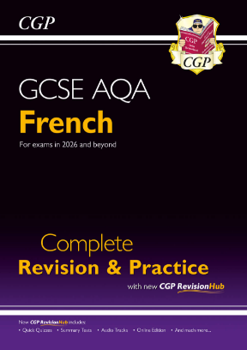  - Complete these pages in your AQA GCSE French Revision & Practice Book.    - **Each week there will also be a Languagenut assignment.  www.languagenut.com  (Log-in with Office 365)  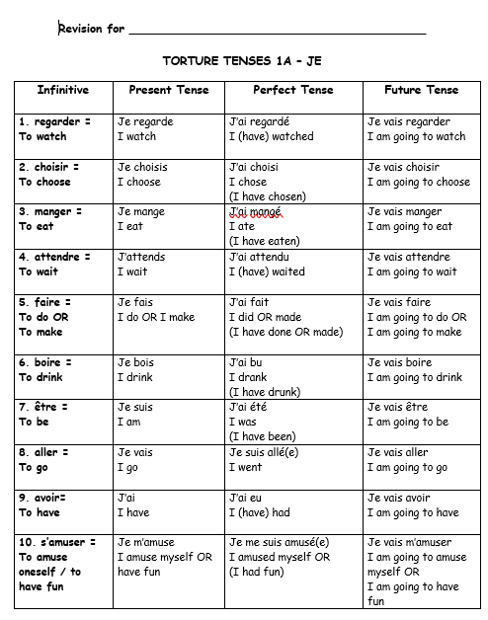  - Students will also be asked to learn Torture Tenses & learn answers to Speaking Questions.
2B | 8-Sep | Topic 1: Identity & Relationships with others  Numbers  Months & Days of the week  Languagenut Assignment
3A | 15-Sep | Opinions  Languagenut Assignment
4B | 22-Sep | General (Numbers, Dates, Questions, Being Polite & Opinions)  P14 Listening Questions  & Languagenut Assignment
5A | 29-Sep | General (Numbers, Dates, Questions, Being Polite & Opinions)  P16 Reading Questions  & Languagenut Assignment
6B | 6-Oct | About yourself  P30 Listening Questions  & Languagenut Assignment
7A | 13-Oct | About yourself  P32 Reading Questions  & Languagenut Assignment
8B | 20-Oct | About yourself  P33 Writing Questions  & Languagenut Assignment
***October Half term***
9A | 3-Nov | Topic 2: Healthy Living & Lifestyle  Food P37 Q1  & Languagenut Assignment
10B | 10-Nov | Lifestyle P39 Q1/Q2  & Languagenut Assignment
11A | 17-Nov | Illness & Treatments P41 Q1/Q2  & Languagenut Assignment
12B | 24-Nov | Healthy Living & Lifestyle  P42 Listening Questions  & Languagenut Assignment
13A | 1-Dec | Healthy Living & Lifestyle  P43 Speaking Questions  & Languagenut Assignment
14B | 8-Dec | Healthy Living & Lifestyle  P44 Reading Questions  & Languagenut Assignment
15A | 15-Dec | Healthy Living & Lifestyle  P45 Writing Questions  & Languagenut Assignment
***Christmas***
16B | 5-Jan | Topic 3: Education & Work  School Subjects P49 Q1  & Languagenut Assignment
17A | 12-Jan | School Life P51 Q1/Q2  & Languagenut Assignment
18B | 19-Jan | School Pressures & Difficulties P53 Q1/Q2  & Languagenut Assignment
19A | 26-Jan | Education  P54 Listening Questions  & Languagenut Assignment
20B | 2-Feb | Education  P56 Reading Questions  & Languagenut Assignment
21A | 9-Feb | Education  P57 Writing Questions  & Languagenut Assignment
***February Half term***
22B | 23-Feb | Career Choices & Ambitions P65 Q1/Q2  & Languagenut Assignment
23A | 2-Mar | Education Post-16  P66 Listening Questions  & Languagenut Assignment
24B | 9-Mar | Education Post-16  P68 Reading Questions  & Languagenut Assignment
25A | 16-Mar | Education Post-16  P69 Writing Questions  & Languagenut Assignment
26B | 23-Mar | Topic 4: Free Time Activities  Music P73 Q1  & Languagenut Assignment
***Easter***
27A | 13-Apr | Cinema, Theatre & TV P75 Q1/Q2  & Languagenut Assignment
28B | 20-Apr | Sport P77 Q1/Q2  & Languagenut Assignment
29A | 27-Apr | Going out & other hobbies P79 Q1/Q2  & Languagenut Assignment
30B | 4-May | Free-Time Activities  P80 Listening Questions  & Languagenut Assignment
31A | 11-May | Free-Time Activities  P82 Reading Questions  & Languagenut Assignment
32B | 18-May | Free-Time Activities  P83 Writing Questions  & Languagenut Assignment
***May Half term***
33A | 1-June | Topic 5: Customs, Festivals & Celebrations  Celebrations P87 Q1  & Languagenut Assignment
34B | 8-June | End of Year 10 Exam Revision
35A | 15-June | Customs & Festivals P89 Q1/Q2  & Languagenut Assignment
36B | 22-June | Customs, Festivals & Celebrations  P90 Listening Questions  & Languagenut Assignment
37A | 29-June | Customs, Festivals & Celebrations  P92 Reading Questions  & Languagenut Assignment
38B | 6-July | Customs, Festivals & Celebrations  P93 Writing Questions  & Languagenut Assignment
39A | 13-July | ASPIRE WEEK

