**AQA Spanish GCSE – Vocabulary**

**Travel and tourism**

**Contents**

|  |  |
| --- | --- |
| Nationalities, countries and regions | 2 |
| Accommodation | 3 |
| Tourist attractions - cities | 4 |
| Tourist attractions – countryside and coast | 7 |
| Food and drink | 9 |
| Seasons, weather and compass points | 10 |
| Transport | 11 |

**Nationalities, countries and regions**

|  |  |  |
| --- | --- | --- |
| adj | alemán | German |
| adj | argentino | Argentinian |
| adj | británico | British |
| adj | chileno | Chilean |
| adj | chino | Chinese |
| adj | colombiano | Colombian |
| adj | cubano | Cuban |
| adj | español | Spanish |
| adj | europeo | European |
| adj | francés | French |
| adj | inglés | English |
| adj | italiano | Italian |
| adj | mexicano | Mexican |
| n (f) | España | Spain |
| n (f) | lengua | tongue, language |
| n (f) | región | region |
| n (f) | Sudamérica | South America |
| n (f) | zona | area, zone |
| n (m) | extranjero | abroad, foreigner (m) |
| n (m) | idioma | language |
| n (m) | mundo | world |
| n (m) | país | country |
| v | comunicar | (to) communicate | communicating |

**Higher only**

|  |  |  |
| --- | --- | --- |
| adj | hispanohablante | Spanish-speaking |
| adj | internacional | international |
| adj | latino | Latin American, Latin |
| adj | nacional | national |
| adj | situado | situated, located |
| n (f) | frontera | border, frontier |
| n (f) | nación | nation |
| n (f) | nacionalidad | nationality |
| n (f) | traducción | translation |

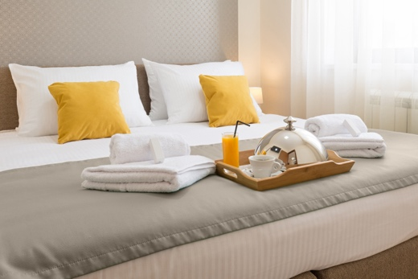

**Accommodation**

|  |  |  |
| --- | --- | --- |
| adj | barato | cheap |
| adj | bienvenido | welcome |
| adj | caro | expensive |
| adj | limpio | clean |
| n (f) | bolsa | bag |
| n (f) | familia | family |
| n (f) | maleta | suitcase |
| n (f) | mochila | rucksack, school bag |
| n (f) | piscina | swimming pool |
| n (f) | planta | plant, floor |
| n (f) | recepción | reception |
| n (f) | tarjeta | written card, bank card |
| n (m) | alojamiento | accommodation |
| n (m) | baño | bathroom |
| n (m) | camping | camp site, camping |
| n (m) | dormitorio | bedroom |
| n (m) | euro | euro |
| n (m) | hotel | hotel |
| n (m) | peso | weight, peso (currency) |
| n (m) | piso | flat, apartment, floor (of building) |
| n (m) | precio | price, cost, value |
| v | buscar | (to) look for, fetch | looking for, fetching |
| v | costar | (to) cost, be hard | costing, being hard |
| v | reservar | (to) book, reserve | booking, reserving |

**Higher only**

|  |  |  |
| --- | --- | --- |
| n (f) | calefacción | heating |
| n (f) | llave | key |
| n (m) | ascensor | lift, elevator |
| n (m) | costo | price, cost |
| n (m) | lujo | luxury |
| n (mpl) | gastos | expenses, costs, spending |
| v | quejarse | (to) complain I complaining |

**Tourist attractions – cities**

|  |  |  |
| --- | --- | --- |
| adj | animado | lively |
| adj | clásico | classic, classical |
| adj | conocido | known, well-known |
| adj | cultural | cultural |
| adj | famoso | famous, well-known |
| adj | hermoso | beautiful, handsome |
| adj | histórico | historic, historical |
| adj | industrial | industrial |
| adj | perdido | lost |
| mwp | centro comercial | shopping centre |
| mwp | dar un paseo | (to) go for a walk, stroll | going for a walk, stroll |
| mwp | pasarlo bien/mal | to have a good/bad time |
| n (f) | arquitectura | architecture |
| n (f) | cámara | camera |
| n (f) | capital | capital (city) |
| n (f) | carretera | road |
| n (f) | compra(s) | shopping |
| n (f) | comunidad | community |
| n (f) | corrida | bullfight |
| n (f) | costumbre | custom, habit, tradition |
| n (f) | cultura | culture |
| n (f) | entrada | entrance, admission ticket |
| n (f) | excursión | trip, excursion |
| n (f) | familia | family |
| n (f) | fiesta | party, festival |
| n (f) | foto | photo, picture |
| n (f) | historia | history, story |
| n (f) | identidad | identity |
| n (f) | iglesia | church |
| n (f) | lista | list, (school) register |
| n (f) | mezquita | mosque |
| n (f) | piscina | swimming pool |
| n (f) | plaza | square |
| n (f) | ropa | clothes, clothing |
| n (f) | sinagoga | synagogue |
| n (f) | tarjeta | written card, bank card |
| n (f) | tienda | shop, tent |
| n (f) | tradición | tradition |
| n (f) | vacaciones; de vacaciones | holidays; on holiday |
| n (f) | zona | area, zone |
| n (m) | ayuntamiento | Spanish town council, city council, town hall |
| n (m) | barrio | neighbourhood, district |
| n (m) | castillo | castle |
| n (m) | desfile | procession, parade |
| n (m) | edificio | building |
| n (m) | espectáculo | show, spectacle |
| n (m) | habitante | local (person), inhabitant |
| n (m) | mercado | market |
| n (m) | museo | museum |
| n (m) | puerto | port, harbour |
| n (m) | recuerdo | memory, souvenir |
| n (m) | río | river |
| n (m) | templo | temple |
| n (m/f) | turista | tourist |
| v | buscar | (to) look for, fetch | looking for, fetching |
| v | comprar | (to) buy, purchase | buying, purchasing |
| v | costar | (to) cost, be hard | costing, being hard |
| v | organizar | (to) organise | organising |
| v | pagar | (to) pay (for) | paying (for) |
| v | perder; perderse | (to) lose, miss | losing, missing; (to) get lost | getting lost |
| v | vender | (to) sell |selling |

**Higher only**

|  |  |  |
| --- | --- | --- |
| adj | situado | situated, located |
| n (f) | exposición | exhibition, display |
| n (f) | pobreza | poverty |
| n (f) | torre | tower |
| n (f) | visita | visit, visitor |
| n (m) | ciudadano | citizen, member of the public |
| n (m) | costo | price, cost |
| n (m) | gobierno | government |
| n (m) | rincón | corner |
| n (m) | turismo | tourism |
| n (m/f) | representante | representative |
| n (mpl) | gastos | expenses, costs, spending |
| v | atraer | (to) attract I attracting |
| v | cobrar | (to) charge (money), earn | charging (money), earning |
| v | contribuir | (to) contribute | contributing |
| v | divertir; divertirse | (to) amuse, entertain I amusing, entertaining; (to) enjoy oneself, have a good time I enjoying oneself, having a good time |
| v | firmar | (to) sign | signing |

**Tourist attractions – countryside and coast**

|  |  |  |
| --- | --- | --- |
| adj | fresco | fresh, cool |
| adj | tranquilo | calm, tranquil, relaxed |
| mwp | dar un paseo | (to) go for a walk, stroll | going for a walk, stroll |
| mwp | pasarlo bien/mal | to have a good/bad time |
| mwp | tomar el sol | (to) sunbathe | sunbathing |
| n (f) | cámara | camera |
| n (f) | costa | coast |
| n (f) | geografía | geography |
| n (f) | isla | island |
| n (f) | montaña | mountain |
| n (f) | planta | plant, floor |
| n (f) | playa | beach |
| n (f) | vacaciones; de vacaciones | holidays; on holiday |
| n (f) | vista | view, sight |
| n (m) | bosque | forest, wood |
| n (m) | campo | countryside, pitch, field |
| n (m) | espacio | space, room |
| n (m) | jardín | garden |
| n (m) | paisaje | landscape |
| n (m) | río | river |
| n (m/f) | mar | sea |
| n (m/f) | turista | tourist |
| v | descansar | (to) rest, relax I resting, relaxing |
| v | disfrutar | (to) enjoy | enjoying |
| v | nadar | (to) swim | swimming |
| v | practicar | (to) practise I practising |
| v | soñar | (to) dream I dreaming |

**Higher only**

|  |  |  |
| --- | --- | --- |
| adj | acuático | water, aquatic |
| adj | situado | situated, located |
| n (f) | arena | sand |
| n (f) | aventura | adventure |
| n (f) | natación | swimming |
| n (f) | visita | visit, visitor |
| n (m) | camino | way, route, path |
| n (m) | lago | lake |
| n (m) | monte | hill, hills, countryside |
| n (m) | turismo | tourism |
| v | atraer | (to) attract I attracting |
| v | caminar | (to) walk | walking |
| v | divertir; divertirse | (to) amuse, entertain I amusing, entertaining; (to) enjoy oneself, have a good time I enjoying oneself, having a good time |
| v | merecer | (to) deserve, be worthy of I deserving, being worthy of |
| v | quemar; quemarse | (to) burn I burning; (to) get sunburnt | getting sunburnt |

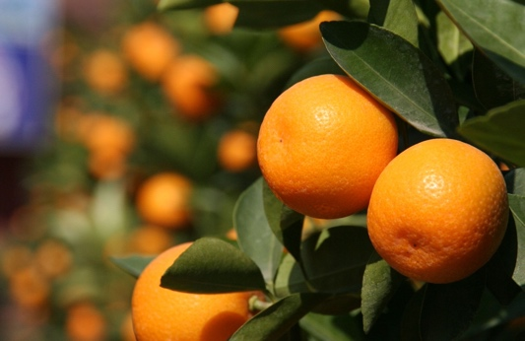

**Food and drink**

|  |  |  |
| --- | --- | --- |
| adj | caliente | hot, warm |
| adj | fresco | fresh, cool |
| adj | frío | cold |
| mwp | patatas fritas | chips, fries |
| n (f) | bebida | drink |
| n (f) | camarera | waitress |
| n (f) | carne | meat |
| n (f) | cena | dinner, evening meal |
| n (f) | comida | food, meal, lunch |
| n (f) | copa | cup, glass |
| n (f) | fruta | fruit |
| n (f) | lista | list, (school) register |
| n (f) | paella | paella (dish usually of rice and seafood) |
| n (fpl) | tapas | small dishes of food, bar snacks |
| n (m) | café | coffee, café |
| n (m) | camarero | waiter |
| n (m) | desayuno | breakfast |
| n (m) | euro | euro |
| n (m) | jamón | ham |
| n (m) | peso | weight, peso (currency) |
| n (m) | plato | plate, dish |
| n (m) | pollo | chicken |
| n (m) | precio | price, cost, value |
| n (m) | restaurante | restaurant |
| n (m) | vino | wine |
| v | comer | (to) eat | eating |
| v | comprar | (to) buy, purchase | buying, purchasing |
| v | costar | (to) cost, be hard | costing, being hard |
| v | pagar | (to) pay (for) | paying (for) |
| v | probar | (to) taste, try | tasting, trying |
| v | reservar | (to) book, reserve | booking, reserving |

**Higher only**

|  |  |  |
| --- | --- | --- |
| n (mpl) | gastos | expenses, costs, spending |
| v | cobrar | (to) charge (money), earn | charging (money), earning |

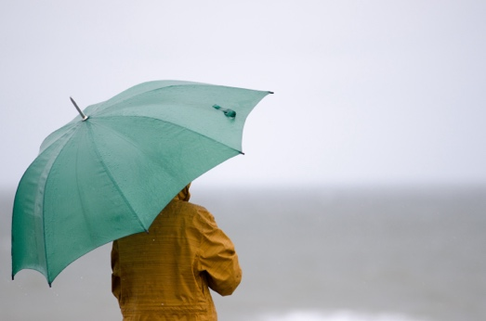

**Seasons, weather and compass points**

|  |  |  |
| --- | --- | --- |
| adj | caliente | hot, warm |
| adj | fresco | fresh, cool |
| adj | frío | cold |
| n (f) | estación | station, season (of the year) |
| n (f) | lluvia | rain |
| n (f) | primavera | spring |
| n (f) | temperatura | temperature |
| n (m) | calor | heat, hot |
| n (m) | clima | climate |
| n (m) | este | east |
| n (m) | grado | degree (temperature) |
| n (m) | invierno | winter |
| n (m) | oeste | west |
| n (m) | otoño | autumn |
| n (m) | pan | bread |
| n (m) | pescado | fish |
| n (m) | sol | sun |
| n (m) | verano | summer |
| n (m) | viento | wind |
| v | llover | (to) rain I raining |

**Transport**

|  |  |  |
| --- | --- | --- |
| adj | directo | direct, straight |
| adj | limpio | clean |
| adj | perdido | lost |
| adj/adv | rápido | quick, fast |
| n (f) | bicicleta, bici | bicycle, bike |
| n (f) | bolsa | bag |
| n (f) | carretera | road |
| n (f) | estación | station, season (of the year) |
| n (f) | excursión | trip, excursion |
| n (f) | lista | list, (school) register |
| n (f) | maleta | suitcase |
| n (f) | mochila | rucksack, school bag |
| n (f) | plaza | square |
| n (f) | salida | exit, departure |
| n (f) | tarjeta | written card, bank card |
| n (f) | vuelta | return, trip, ride |
| n (m) | aeropuerto | airport |
| n (m) | autobús | bus |
| n (m) | avión | plane, aeroplane |
| n (m) | barco | boat, ship |
| n (m) | billete | ticket (for transport) |
| n (m) | coche | car |
| n (m) | kilómetro | kilometre |
| n (m) | metro | underground, tube, metro, metre |
| n (m) | pie; a pie | foot; on foot |
| n (m) | plano | map |
| n (m) | tráfico | traffic |
| n (m) | transporte | transport |
| n (m) | tren | train |
| n (m) | viaje | trip, journey |
| n (m) | vuelo | flight |
| v | buscar | (to) look for, fetch | looking for, fetching |
| v | coger | (to) take, take hold of, catch | taking, taking hold of, catching |
| v | comprar | (to) buy, purchase | buying, purchasing |
| v | conducir | (to) drive | driving |
| v | costar | (to) cost, be hard | costing, being hard |
| v | descansar | (to) rest, relax I resting, relaxing |
| v | disfrutar | (to) enjoy | enjoying |
| v | montar | (to) ride, set up I riding, setting up |
| v | pagar | (to) pay (for) | paying (for) |
| v | perder; perderse | (to) lose, miss | losing, missing; (to) get lost | getting lost |
| v | viajar | (to) travel | travelling |
| v | visitar | (to) visit | visiting |

**Higher only**

|  |  |  |
| --- | --- | --- |
| adj | acuático | water, aquatic |
| n (f) | distancia | distance |
| n (f) | llegada | arrival |
| n (f) | velocidad | speed, velocity |
| n (m) | camino | way, route, path |
| n (m) | costo | price, cost |
| n (m) | destino | destination, destiny |
| n (m) | documento | document |
| n (m) | retraso | delay |
| n (mpl) | gastos | expenses, costs, spending |
| v | alquilar | (to) hire, rent | hiring, renting |
| v | caminar | (to) walk | walking |
| v | cobrar | (to) charge (money), earn | charging (money), earning |
| v | cruzar | (to) cross | crossing |
| v | quejarse | (to) complain I complaining |