**AQA French GCSE – Vocabulary**

**Travel and tourism**

**Contents**

|  |  |
| --- | --- |
| Nationalities, countries and regions | 2 |
| Accommodation | 4 |
| Tourist attractions - cities | 5 |
| Tourist attractions – countryside and coast | 7 |
| Food and drink | 9 |
| Seasons, weather and compass points | 10 |
| Transport | 11 |

**Nationalities, countries and regions**

|  |  |  |
| --- | --- | --- |
| adj | allemand | German (m) |
| adj | américain | American (m) |
| adj | anglais | English (m) |
| adj | britannique | British (m, f) |
| adj | canadien | Canadian (m) |
| adj | espagnol | Spanish (m) |
| adj | étranger* | foreign (m) |
| adj | français | French (m) |
| adj | international | international (m) |
| adj | national | national (m) |
| adj | régional | regional (m) |
| n (f) | Angleterre | England |
| n (f) | Belgique | Belgium |
| n (f) | France | France |
| n (f) | géographie | geography |
| n (f) | identité | identity |
| n (f) | La Réunion | Reunion Island |
| n (f) | langue | language, tongue |
| n (f) | Manche | English Channel |
| n (f) | Méditerranée | the Mediterranean |
| n (f) | région | region, area |
| n (f) | Suisse | Switzerland |
| n (f) | vacances | holiday |
| n (m) | Canada | Canada |
| n (m) | étranger** | foreigner, stranger, abroad |
| n (m) | Européen | European |
| n (m) | habitant | resident (m) |
| n (m) | Maroc | Morocco |
| n (m) | Paris | Paris |
| n (m) | pays | country |
| n (m) | Québec | Quebec |
| n (m) | Sénégal | Senegal |
| v | traduire | (to) translate | translating |

**Higher only**

|  |  |  |
| --- | --- | --- |
| adj | africain | African (m) |
| adj | arabe | Arabic, Arab (m, f) |
| adj | belge | Belgian (m, f) |
| adj | central | central (m) |
| adj | chinois | Chinese (m) |
| adj | francophone | French-speaking (m, f) |
| adj | global | global (m) |
| adj | marocain | Moroccan (m) |
| adj | mondial | worldwide, global (m) |
| adj | occidental | western (m) |
| adj | québécois | from Quebec (m) |
| adj | suisse | Swiss (m, f) |
| n (f) | Afrique | Africa |
| n (f) | Asie | Asia |
| n (f) | Corse | Corsica |
| n (f) | Europe | Europe |
| n (f) | frontière | border |
| n (f) | province | province |
| n (f) | Tunisie | Tunisia |
| n (m) | Londres | London |

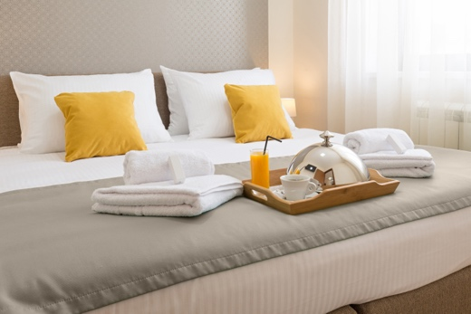

**Accommodation**

|  |  |  |
| --- | --- | --- |
| adj | cher | expensive (m) |
| adj | idéal | ideal (m) |
| adj | propre | clean, proper, own (m, f) |
| n (f) | chambre | bedroom |
| n (f) | piscine | swimming pool |
| n (f) | place | room, space, square, place |
| n (f) | porte | door |
| n (f) | sortie | exit |
| n (f) | toilette | washing, toilet, lavatory, bathroom, restroom |
| n (m) | appartement | apartment, flat |
| n (m) | argent | money |
| n (m) | camping | camping |
| n (m) | euro | euro |
| n (m) | hôtel | hotel |
| n (m) | logement | accommodation |
| v | dormir | (to) sleep | sleeping |
| v | rechercher | (to) look for, collect | looking for, collecting |
| v | réserver | (to) reserve, book, keep │ reserving, booking, keeping |
| v | rester | (to) stay, remain | staying, remaining |

**Higher only**

|  |  |  |
| --- | --- | --- |
| adj | étroit | narrow, tight (m) |
| n (f) | plainte | moan, complaint |
| n (f) | réception | reception |
| n (m) | accueil | welcome, reception |
| n (m) | étage | floor |
| n (m) | séjour | stay |
| n (m) | sol | floor, ground |

**Tourist attractions – cities**

|  |  |  |
| --- | --- | --- |
| adj | beau/bel | beautiful (m) |
| adj | beaux | beautiful (mpl, mixed gender pl) |
| adj | belle | beautiful (f) |
| adj | historique | historic (m, f) |
| adj | industriel | industrial (m) |
| n (f) | capitale | capital city |
| n (f) | course | race, shopping |
| n (f) | culture | culture |
| n (f) | découverte | discovery |
| n (f) | église | church |
| n (f) | entrée | entrance, starter |
| n (f) | mosquée | mosque |
| n (f) | photo | photo |
| n (f) | piscine | swimming pool |
| n (f) | place | room, space, square, place |
| n (f) | synagogue | synagogue |
| n (f) | tradition | tradition |
| n (f) | ville | town |
| n (f) | visite | visit, tour |
| n (fpl) | Alpes | Alps |
| n (fpl) | Pyrénées | the Pyrenees |
| n (m) | argent | money |
| n (m) | bâtiment | building |
| n (m) | centre | centre |
| n (m) | château | castle, palace |
| n (m) | défilé | parade, procession |
| n (m) | échange | exchange |
| n (m) | endroit | place, spot |
| n (m) | festival | festival |
| n (m) | habitant | resident (m) |
| n (m) | jardin | garden |
| n (m) | lieu | place |
| n (m) | magasin | shop |
| n (m) | marché | market |
| n (m) | musée | museum |
| n (m) | parc | park |
| n (m) | pont | bridge |
| n (m) | quartier | district, quarter |
| n (m) | shopping | shopping |
| n (m) | site | site |
| n (m) | spectacle | sight, show |
| n (m) | stade | stadium, stage |
| n (m) | supermarché | supermarket |
| n (m) | temple | temple |
| n (m) | touriste | tourist |
| v | acheter | (to) buy | buying |
| v | apprendre; apprendre à … | (to) learn | learning; (to) teach someone | teaching someone |
| v | communiquer | (to) pass on, communicate | passing on, communicating |
| v | coûter | (to) cost | costing |
| v | découvrir | (to) discover | discovering |
| v | organiser; s'organiser | (to) organise | organising; (to) get organised | getting organised |
| v | situer; se situer | (to) place, put, situate | placing, putting, situating; (to) be situated, take place | being situated, taking place |
| v | visiter | (to) visit | visiting |

**Higher only**

|  |  |  |
| --- | --- | --- |
| adj | étroit | narrow, tight (m) |
| adj | vif | lively (m) |
| n (f) | foi | faith |
| n (f) | tournée | tour, round |
| v | contribuer | (to) contribute | contributing |
| v | pratiquer | (to) do, play, practise (a language)|doing, playing, practising (a language) |

**Tourist attractions – countryside and coast**

|  |  |  |
| --- | --- | --- |
| adj | beau/bel | beautiful (m) |
| adj | beaux | beautiful (mpl, mixed gender pl) |
| adj | belle | beautiful (f) |
| adj | calme | calm, quiet (m, f) |
| adv | dehors | outside |
| n (f) | campagne | countryside |
| n (f) | côte | coast |
| n (f) | ferme | farm, firm |
| n (f) | forêt | forest |
| n (f) | île | island |
| n (f) | mer | sea |
| n (f) | montagne | mountain |
| n (f) | natation | swimming |
| n (f) | nature | nature |
| n (f) | plage | beach |
| n (f) | promenade | walk |
| n (f) | vue | view |
| n (fpl) | Alpes | Alps |
| n (fpl) | Pyrénées | the Pyrenees |
| n (m) | bord | edge, side |
| n (m) | ciel | sky |
| n (m) | endroit | place, spot |
| n (m) | jardin | garden |
| n (m) | lieu | place |
| n (m) | parc | park |
| n (m) | rêve | dream |
| n (m) | site | site |
| n (m) | village | village |
| v | rêver (à/de + noun) | (to) dream (about + noun) | dreaming (about + noun) |
| v | se relaxer | (to) relax | relaxing |

**Higher only**

|  |  |  |
| --- | --- | --- |
| n (f) | rivière | river |
| n (f) | vague | wave |
| n (m) | lac | lake |
| n (m) | paysage | landscape, scenery, countryside |
| v | mériter (de + infinitive); se mériter | (to) deserve (+ verb) | deserving (+ verb); (to) have earned | having earned |
| v | nager | (to) swim | swimming |
| v | profiter de + noun | (to) make the most of + noun, enjoy + noun | making the most of + noun, enjoying + noun |

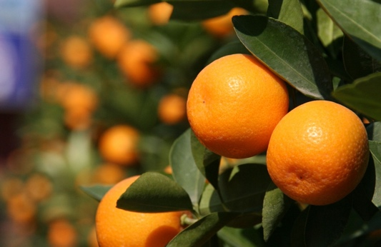

**Food and drink**

|  |  |  |
| --- | --- | --- |
| n (f) | boisson | drink, beverage |
| n (f) | carte | menu, map, card |
| n (f) | cuisine | cooking, kitchen |
| n (f) | entrée | entrance, starter |
| n (f) | fête | party, festival |
| n (f) | glace | ice cream, ice |
| n (f) | nourriture | food |
| n (f) | viande | meat |
| n (fpl) | frites | chips |
| n (m) | café | café, coffee |
| n (m) | déjeuner | lunch |
| n (m) | dîner | dinner |
| n (m) | fromage | cheese |
| n (m) | fruit | fruit |
| n (m) | gâteau | cake |
| n (m) | légume | vegetable |
| n (m) | pain | bread |
| n (m) | petit-déjeuner | breakfast |
| n (m) | poisson | fish |
| n (m) | repas | meal |
| n (m) | restaurant | restaurant |
| n (m) | serveur | waiter, server |
| n (m) | thé | tea |
| v | manger | (to) eat | eating |
| v | réserver | (to) reserve, book, keep │ reserving, booking, keeping |

**Higher only**

|  |  |  |
| --- | --- | --- |
| n (f) | addition | bill |
| n (m) | plat | dish |
| n (m) | poulet | chicken |
| n (m) | verre | glass |
| v | commander; commander à … de + infinitive | (to) order | ordering; (to) tell someone + verb | telling someone + verb |

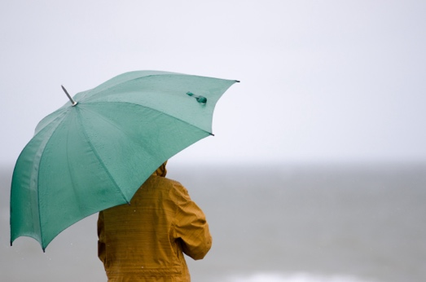

**Seasons, weather and compass points**

|  |  |  |
| --- | --- | --- |
| adj | chaud | hot, warm (m) |
| adj | froid | cold (m) |
| n (f) | neige | snow |
| n (f) | saison | season |
| n (m) | automne | autumn |
| n (m) | brouillard | fog, mist, haze |
| n (m) | ciel | sky |
| n (m) | climat | climate |
| n (m) | été | summer |
| n (m) | hiver | winter |
| n (m) | nord | north |
| n (m) | ouest | west |
| n (m) | printemps | spring |
| n (m) | soleil | sun |
| n (m) | sud | south |
| n (m) | temps | time, weather |
| n (m) | vent | wind |

**Higher only**

|  |  |  |
| --- | --- | --- |
| n (f) | météo | weather forecast |
| n (f) | pluie | rain |
| n (m) | est** | east |
| n (m) | manteau | coat |

**Transport**

|  |  |  |
| --- | --- | --- |
| adj | cher | expensive (m) |
| adj | rapide | fast, quick (m, f) |
| adv | vite | quickly, fast |
| n (f) | arrivée | arrival |
| n (f) | carte | menu, map, card |
| n (f) | gare | station, railway station |
| n (f) | sortie | exit |
| n (f) | station | station |
| n (f) | urgence | emergency |
| n (f) | voiture | car |
| n (m) | aéroport | airport |
| n (m) | autobus/bus | bus |
| n (m) | avion | aeroplane |
| n (m) | bateau | boat, ship |
| n (m) | billet | ticket |
| n (m) | départ | departure |
| n (m) | échange | exchange |
| n (m) | kilomètre | kilometre |
| n (m) | mètre | metre |
| n (m) | projet | plan |
| n (m) | retour | return |
| n (m) | sac | bag, sack |
| n (m) | train | train |
| n (m) | transport | transportation |
| n (m) | vélo | bike, bicycle |
| n (m) | vol | flight, theft |
| n (m) | voyage | trip, journey |
| v | arriver; arriver à + infinitive | (to) arrive | arriving; (to) manage + verb, succeed in + verb | managing + verb, succeeding in + verb |
| v | partir | (to) leave | leaving |
| v | perdre; se perdre | (to) lose | losing; (to) get lost | getting lost |
| v | quitter; se quitter | (to) leave somewhere, take off | leaving somewhere, taking off; (to) leave each other | leaving each other |
| v | retourner | (to) return, go back, turn over, turn around | returning, going back, turning over, turning around |
| v | revenir | (to) come back, return | coming back, returning |
| v | sortir | (to) go out, exit, take out, release | going out, exiting, taking out, releasing |
| v | traverser | (to) cross | crossing |
| v | voler (à ...) | (to) fly, steal (from someone) | flying, stealing (from someone) |
| v | voyager | (to) travel (around) | travelling (around) |

**Higher only**

|  |  |  |
| --- | --- | --- |
| adj | direct | direct (m) |
| adv | autour | around |
| n (f) | circulation | traffic |
| n (f) | direction | direction, management |
| n (f) | distance | distance |
| n (f) | durée | length, duration |
| n (f) | tournée | tour, round |
| n (f) | valise | suitcase |
| n (f) | vitesse | speed |
| n (m) | attentat | attack, assassination attempt |
| n (m) | bagage | luggage, baggage |
| n (m) | métro | underground, metro |
| n (m) | retard | delay |
| n (m) | ticket | ticket |
| v | abandonner | (to) give up, abandon | giving up, abandoning |
| v | accompagner | (to) accompany | accompanying |