**AQA French GCSE – Vocabulary**

**Celebrity Culture**



**Contents**

|  |  |
| --- | --- |
| Foundation & Higher | 2 |
| Higher only | 4 |

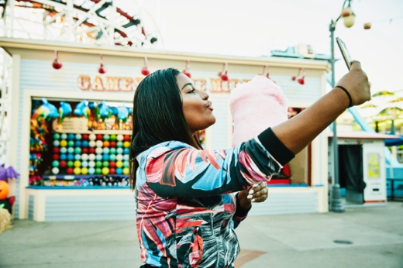

**Foundation & Higher**

|  |  |  |
| --- | --- | --- |
| adj | célèbre | famous (m) |
| adj | culturel | cultural (m) |
| adj | extraordinaire | extraordinary (m, f) |
| adj | fier | proud (m) |
| adj | international | international (m) |
| adj | local | local (m) |
| adj | national | national (m) |
| adj | populaire | popular (m, f) |
| adj | public | public (m) |
| adj | publique | public (f) |
| adj | riche | rich (m, f) |
| adj | spécial | special (m) |

|  |  |  |
| --- | --- | --- |
| n (f) | carrière | career |
| n (f) | célébrité | celebrity |
| n (f) | chanson | song |
| n (f) | émission | TV programme |
| n (f) | équipe | team |
| n (f) | génération | generation |
| n (f) | identité | identity |
| n (f) | influence | influence |
| n (f) | mode | way, fashion |
| n (f) | musique | music |
| n (f) | personnalité | personality |
| n (f) | photo | photo |
| n (f) | politique | politics |
| n (f) | réalité | reality |
| n (f) | star | star, celebrity |
| n (f) | télévision/télé | television/TV |
| n (f) | vidéo | video |
| n (fpl) | paroles | lyrics |
| n (m, f) | artiste | artist |
| n (m, f) | auteur | author |
| n (m) | acteur | actor (m) |
| n (m) | argent | money |
| n (m) | chanteur | singer |
| n (m) | cinéma | cinema |
| n (m) | concert | concert |
| n (m) | écrivain | writer |
| n (m) | entretien | interview, maintenance |
| n (m) | film | film |
| n (m) | groupe | group |
| n (m) | influenceur | influencer |
| n (m) | internet | internet |
| n (m) | journal | newspaper |
| n (m) | mariage | marriage, wedding |
| n (m) | monde | world |
| n (m) | personnage | character, individual, person |
| n (m) | prix | price, prize |
| n (m) | selfie | selfie |
| n (m) | spectacle | sight, show |
| n (m) | sport | sport |
| n (m) | style | style |
| n (m) | succès | success |
| n (m) (f) | tour | turn, tour, tower |
| n (mpl) | journaux | newspapers |
| n (mpl) | médias | media |

|  |  |  |
| --- | --- | --- |
| v | chanter | (to) sing | singing |
| v | écouter | (to) listen to | listening to |
| v | jouer (à/de + noun) | (to) play (+ noun) | playing (+ noun) |
| v | porter | (to) wear, carry | wearing, carrying |
| v | regarder | (to) watch, look at | watching, looking at |
| v | suivre | (to) follow | following |



**Higher Only**

|  |  |  |
| --- | --- | --- |
| adj | francophone | French-speaking (m, f) |
| adj | puissant | powerful (m) |
| adj | unique | unique (m, f) |

|  |  |  |
| --- | --- | --- |
| n (f) | héroïne | hero (f) |
| n (f) | image | picture, image |
| n (f) | marque | brand, mark |
| n (f) | ouverture | opening |
| n (f) | presse | press |
| n (f) | richesse | wealth |
| n (f) | série | series |
| n (f) | tournée | tour, round |
| n (f) | victime | victim |
| n (f) | voix | voice |
| n (m) | héros | hero (m) |
| n (m) | public** | public, audience |
| n (m) | rôle | role |
| n (m) | scandale | scandal, uproar |

|  |  |  |
| --- | --- | --- |
| v | annoncer | (to) announce, make public | announcing, making public |
| v | diriger; se diriger | (to) direct, guide | directing, guiding; (to) make one's way | making one's way |
| v | inspirer; s'inspirer de + noun | (to) inspire | inspiring; (to) be inspired by + noun | being inspired by + noun |
| v | présenter; présenter ... à | (to) present, show | presenting, showing; (to) introduce someone to | introducing someone to |
| v | reconnaître | (to) recognise | recognising |
| v | respecter | (to) respect | respecting |