**AQA French GCSE – Vocabulary**

**Customs, Festivals and Celebrations**

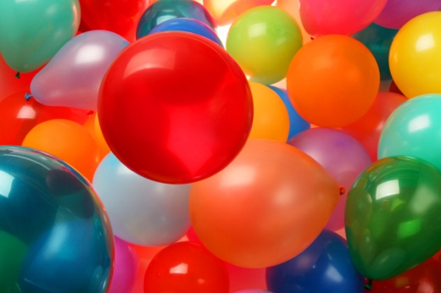

**Contents**

|  |  |
| --- | --- |
| Religion | 2 |
| Parties and celebrations | 3 |
| Festivals and holidays | 5 |
| Food and drink | 6 |

**Religion**

|  |  |  |
| --- | --- | --- |
| adj | bouddhiste | Buddhist (m, f) |
| adj | chrétien | Christian (m) |
| adj | juif | Jewish (m) |
| adj | musulman | Muslim (m) |
| adj | religieux | religious (m) |
| n (f) | église | church |
| n (f) | mosquée | mosque |
| n (f) | religion | religion |
| n (f) | synagogue | synagogue |
| n (m) | temple | temple |
| v | croire | (to) believe | believing |

**Higher only**

|  |  |  |
| --- | --- | --- |
| adj | catholique | Catholic (m, f) |
| n (f) | foi | faith |
| n (m) | dieu | god |
| v | prier | (to) pray | praying |

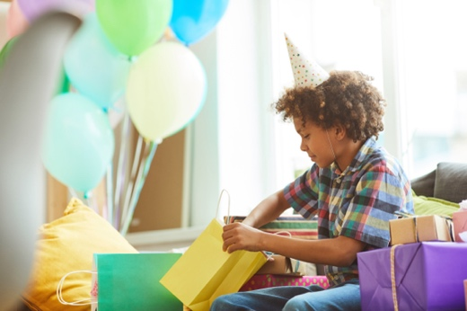

**Parties and celebrations**

|  |  |  |
| --- | --- | --- |
| adj | folle | crazy (f) |
| adj | fou | crazy (m) |
| intj | félicitations | congratulations |
| mwp | feu d'artifice | firework display |
| n (f) | anniversaire | birthday |
| n (f) | chanson | song |
| n (f) | date | date |
| n (f) | expérience | experience |
| n (f) | fête | party, festival |
| n (f) | fleur | flower |
| n (f) | lumière | light |
| n (f) | musique | music |
| n (f) | participation | participation |
| n (f) | surprise | surprise |
| n (m) | bruit | noise |
| n (m) | cadeau | present, gift |
| n (m) | concert | concert |
| n (m) | événement | event |
| n (m) | feu | fire |
| n (m) | intérêt | interest |
| n (m) | mariage | marriage, wedding |
| n (m) | PACS | civil partnership |
| n (m) | spectacle | sight, show |
| n (m) | vêtement | garment, item or article of clothing |
| v | acheter | (to) buy | buying |
| v | célébrer | (to) celebrate | celebrating |
| v | chanter | (to) sing | singing |
| v | communiquer | (to) pass on, communicate | passing on, communicating |
| v | danser | (to) dance | dancing |
| v | découvrir | (to) discover | discovering |
| v | donner | (to) give | giving |
| v | envoyer | (to) send | sending |
| v | inviter | (to) invite | inviting |
| v | marier; se marier (avec) | (to) marry | marrying; (to) get married (to) | getting married (to) |
| v | organiser; s'organiser | (to) organise | organising; (to) get organised | getting organised |
| v | partager | (to) share | sharing |
| v | participer à + noun | (to) take part in + noun, participate in + noun | taking part in + noun, participating in + noun |
| v | passer; se passer | (to) spend time, pass | spending time, passing time; (to) happen | happening |
| v | porter | (to) wear, carry | wearing, carrying |
| v | préparer; se préparer | (to) prepare | preparing; (to) get ready | getting ready |
| v | recevoir | (to) receive | receiving |
| v | regarder | (to) watch, look at | watching, looking at |
| v | surprendre | (to) surprise | surprising |

**Higher only**

|  |  |  |
| --- | --- | --- |
| adj | joyeux | merry, joyful, happy (m) |
| adj | vif | lively (m) |
| n (f) | joie | joy |
| n (m) | bonheur | happiness |
| v | assister; assister à + noun | (to) assist | assisting; (to) attend + noun | attending + noun |
| v | brûler | (to) burn, be on fire | burning, being on fire |
| v | féliciter | (to) congratulate | congratulating |
| v | lancer | (to) throw, launch | throwing, launching |
| v | profiter de + noun | (to) make the most of + noun, enjoy + noun | making the most of + noun, enjoying + noun |
| v | unir | (to) unite, join | uniting, joining |

**Festivals and holidays**

|  |  |  |
| --- | --- | --- |
| adj | culturel | cultural (m) |
| adj | familial | family (m) |
| adj | férié | public holiday (m) |
| adj | historique | historic (m, f) |
| adj | international | international (m) |
| adj | local | local (m) |
| adj | national | national (m) |
| adj | régional | regional (m) |
| adj | spécial | special (m) |
| adj | traditionnel | traditional (m) |
| n (f) | culture | culture |
| n (f) | Fête Nationale | Bastille Day, French national holiday |
| n (f) | Saint Valentin | Valentine's Day |
| n (f) | société | society |
| n (f) | tradition | tradition |
| n (f) | vacances | holiday |
| n (f) | visite | visit, tour |
| n (m) | Aïd | Eid |
| n (m) | défilé | parade, procession |
| n (m) | Européen | European |
| n (m) | festival | festival |
| n (m) | le Tour de France | Tour de France |
| n (m) | monde | world |
| n (m) | Noël | Christmas |
| n (m) | Pâques | Easter |

**Higher only**

|  |  |  |
| --- | --- | --- |
| adj | belge | Belgian (m, f) |
| adj | francophone | French-speaking (m, f) |
| adj | joyeux | merry, joyful, happy (m) |
| n (f) | diversité | diversity |
| n (f) | humanité | humanity |
| n (m) | roi | king |

**Food and drink**

|  |  |  |
| --- | --- | --- |
| n (f) | cuisine | cooking, kitchen |
| n (m) | gâteau | cake |
| n (m) | repas | meal |
| n (m) | vin | wine |
| v | réserver | (to) reserve, book, keep │ reserving, booking, keeping |

**Higher only**

|  |  |  |
| --- | --- | --- |
| n (m) | plat | dish |