**AQA French GCSE – Vocabulary**

**Free time Activities**

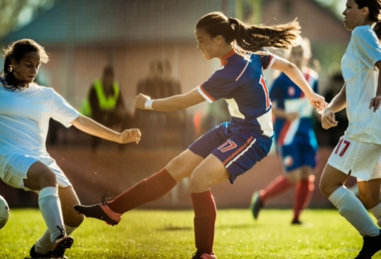

**Contents**

|  |  |
| --- | --- |
| Opinions about free time activities | 2 |
| Sports & physical activities | 3 |
| Food and drink | 5 |
| Cultural activities - TV, film, reading, music and museums | 7 |
| Shopping | 9 |
| Social media and gaming | 10 |

**Opinions about free time activities**

|  |  |  |
| --- | --- | --- |
| adj | dangereux | dangerous (m) |
| adj | difficile | difficult (m, f) |
| adj | dur* | hard (m) |
| adj | facile | easy (m, f) |
| adj | passionnant | exciting, thrilling (m) |
| adj | populaire | popular (m, f) |
| adv | dur** | hard |
| n (f) | copine | friend, girlfriend |
| n (m) | ami | friend (m) |
| n (m) | amour | love |
| n (m) | copain | friend (m), boyfriend |
| n (m) | danger | danger |
| n (m) | défi | challenge |
| n (m) | intérêt | interest |
| n (m) | passe-temps | hobby |
| n (m) | temps | time, weather |
| v | célébrer | (to) celebrate | celebrating |
| v | disputer; se disputer | (to) scold, tell off | scolding, telling off; (to) argue │ arguing |
| v | essayer (de + infinitive) | (to) try (+ verb), attempt (+verb) | trying (+ verb), attempting (+ verb) |
| v | rencontrer | (to) meet, run into | meeting, running into |
| v | rire | (to) laugh | laughing |
| v | se relaxer | (to) relax | relaxing |
| v | sortir | (to) go out, exit, take out, release | going out, exiting, taking out, releasing |

**Higher only**

|  |  |  |
| --- | --- | --- |
| n (f) | météo | weather forecast |
| n (f) | passion | passion |
| n (m) | risque | risk |
| v | profiter de + noun | (to) make the most of + noun, enjoy + noun | making the most of + noun, enjoying + noun |
| v | risquer (de + infinitive) | (to) risk (+ verb) | risking (+ verb) |

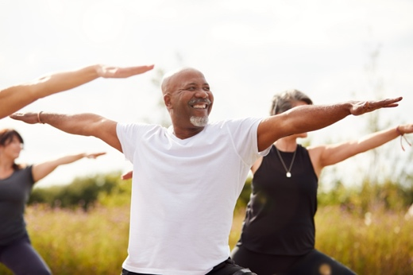

**Sports & physical activities**

|  |  |  |
| --- | --- | --- |
| adj | actif | active, energetic (m) |
| adj | sportif | athletic, competitive, sporty, sporting (m) |
| adv | vite | quickly, fast |
| n (f) | action | action |
| n (f) | activité | activity |
| n (f) | course | race, shopping |
| n (f) | équipe | team |
| n (f) | montagne | mountain |
| n (f) | natation | swimming |
| n (f) | participation | participation |
| n (f) | partie | part, game, match |
| n (f) | piscine | swimming pool |
| n (f) | plage | beach |
| n (f) | promenade | walk |
| n (f) | santé | health |
| n (f) | visite | visit, tour |
| n (m) | but | goal, aim, objective, purpose |
| n (m) | camping | camping |
| n (m) | concours | entrance exam, competition |
| n (m) | exercice | written exercise, physical exercise |
| n (m) | foot(ball) | football, soccer |
| n (m) | jeu | game |
| n (m) | le Tour de France | Tour de France |
| n (m) | match | match |
| n (m) | membre | member |
| n (m) | parc | park |
| n (m) | soleil | sun |
| n (m) | sport | sport |
| n (m) | stade | stadium, stage |
| n (m) | vélo | bike, bicycle |
| n (m) | voyage | trip, journey |
| v | courir | (to) run | running |
| v | danser | (to) dance | dancing |
| v | jouer (à/de + noun) | (to) play (+ noun) | playing (+ noun) |
| v | marcher | (to) walk, work | walking, working |
| v | monter; monter (à + noun) | (to) go up | going up; (to) climb (up + noun) | climbing (up + noun) |
| v | participer à + noun | (to) take part in + noun, participate in + noun | taking part in + noun, participating in + noun |
| v | perdre; se perdre | (to) lose | losing; (to) get lost | getting lost |
| v | situer; se situer | (to) place, put, situate | placing, putting, situating; (to) be situated, take place | being situated, taking place |
| v | visiter | (to) visit | visiting |

**Higher only**

|  |  |  |
| --- | --- | --- |
| n (f) | concurrence | competition |
| n (f) | formation | training |
| n (f) | rivière | river |
| n (f) | vitesse | speed |
| n (m) | terrain | ground, terrain |
| v | blesser | (to) hurt, injure | hurting, injuring |
| v | diriger; se diriger | (to) direct, guide | directing, guiding; (to) make one's way | making one's way |
| v | mener | (to) lead | leading |
| v | nager | (to) swim | swimming |
| v | pratiquer | (to) do, play, practise (a language)|doing, playing, practising (a language) |

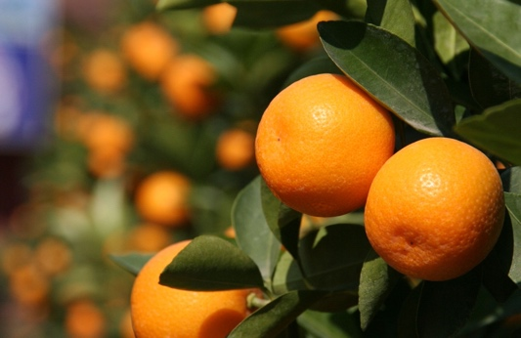

**Food and drink**

|  |  |  |
| --- | --- | --- |
| adj | complet | full, complete (m) |
| adj | ouvert | open (m) |
| n (f) | boisson | drink, beverage |
| n (f) | carte | menu, map, card |
| n (f) | entrée | entrance, starter |
| n (f) | glace | ice cream, ice |
| n (f) | nourriture | food |
| n (f) | recette | recipe |
| n (f) | soif | thirst |
| n (f) | table | table |
| n (f) | viande | meat |
| n (fpl) | courses | food shopping |
| n (fpl) | frites | chips |
| n (m) | café | café, coffee |
| n (m) | dîner | dinner |
| n (m) | fromage | cheese |
| n (m) | fruit | fruit |
| n (m) | gâteau | cake |
| n (m) | goût | taste, flavour |
| n (m) | légume | vegetable |
| n (m) | poisson | fish |
| n (m) | prix | price, prize |
| n (m) | repas | meal |
| n (m) | restaurant | restaurant |
| n (m) | serveur | waiter, server |
| n (m) | thé | tea |
| n (m) | vin | wine |
| v | boire | (to) drink | drinking |
| v | emporter | (to) take with, take away | taking with, taking away |
| v | fermer | (to) close, shut | closing, shutting |
| v | manger | (to) eat | eating |
| v | ouvrir | (to) open | opening |
| v | recommander | (to) recommend | recommending |
| v | réserver | (to) reserve, book, keep │ reserving, booking, keeping |

**Higher only**

|  |  |  |
| --- | --- | --- |
| adj | complète | full, complete (f) |
| n (f) | addition | bill |
| n (m) | consommateur | consumer, customer |
| n (m) | couteau | knife |
| n (m) | plat | dish |
| n (m) | poulet | chicken |
| n (m) | verre | glass |
| v | commander; commander à … de + infinitive | (to) order | ordering; (to) tell someone + verb | telling someone + verb |



**Cultural activities - TV, film, reading, music and museums**

|  |  |  |
| --- | --- | --- |
| n (f) | action | action |
| n (f) | chanson | song |
| n (f) | culture | culture |
| n (f) | émission | TV programme |
| n (f) | fête | party, festival |
| n (f) | lecture | reading |
| n (f) | musique | music |
| n (f) | pièce | piece, room, play |
| n (f) | radio | radio |
| n (f) | réalité | reality |
| n (f) | télévision/télé | television/TV |
| n (f) | vidéo | video |
| n (fpl) | paroles | lyrics |
| n (m, f) | artiste | artist |
| n (m, f) | auteur | author |
| n (m) | acteur | actor (m) |
| n (m) | article | article, item |
| n (m) | billet | ticket |
| n (m) | chanteur | singer |
| n (m) | cinéma | cinema |
| n (m) | club | club |
| n (m) | concert | concert |
| n (m) | événement | event |
| n (m) | festival | festival |
| n (m) | film | film |
| n (m) | groupe | group |
| n (m) | instrument | instrument |
| n (m) | journal | newspaper |
| n (m) | membre | member |
| n (m) | musée | museum |
| n (m) | personnage | character, individual, person |
| n (m) | roman | novel |
| n (m) | tableau | board, picture, painting |
| n (m) | théâtre | theatre, drama |
| n (m) | voyage | trip, journey |
| n (m) (f) | livre | book, pound |
| n (mpl) | journaux | newspapers |
| v | célébrer | (to) celebrate | celebrating |
| v | chanter | (to) sing | singing |
| v | écouter | (to) listen to | listening to |
| v | écrire | (to) write | writing |
| v | lire | (to) read | reading |
| v | regarder | (to) watch, look at | watching, looking at |
| v | sortir | (to) go out, exit, take out, release | going out, exiting, taking out, releasing |

**Higher only**

|  |  |  |
| --- | --- | --- |
| n (f) | ouverture | opening |
| n (f) | scène | stage, scene |
| n (f) | série | series |
| n (m) | art | art |
| n (m) | chapitre | chapter |
| n (m) | genre | type, kind, sort |
| n (m) | public** | public, audience |
| n (m) | rôle | role |
| n (m) | rythme | rhythm, rate |
| n (m) | ticket | ticket |
| v | dessiner | (to) draw | drawing |

**Shopping**

|  |  |  |
| --- | --- | --- |
| adj | commercial | commercial, shopping (m) |
| adj | ouvert | open (m) |
| n (f) | caisse | checkout |
| n (f) | carte | menu, map, card |
| n (f) | course | race, shopping |
| n (f) | mode | way, fashion |
| n (f) | place | room, space, square, place |
| n (f) | taille | size, height |
| n (fpl) | courses | food shopping |
| n (m) | article | article, item |
| n (m) | billet | ticket |
| n (m) | centre | centre |
| n (m) | euro | euro |
| n (m) | pantalon | trousers |
| n (m) | prix | price, prize |
| n (m) | sac | bag, sack |
| n (m) | shopping | shopping |
| n (m) | style | style |
| n (m) | vêtement | garment, item or article of clothing |
| v | acheter | (to) buy | buying |
| v | coûter | (to) cost | costing |
| v | fermer | (to) close, shut | closing, shutting |
| v | ouvrir | (to) open | opening |
| v | payer | (to) pay (for) | paying (for) |

**Higher only**

|  |  |  |
| --- | --- | --- |
| n (m) | achat | purchase |
| n (m) | chapeau | hat |
| n (m) | consommateur | consumer, customer |
| n (m) | impôt | tax |
| n (m) | ticket | ticket |

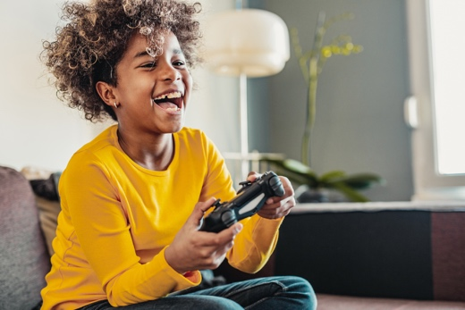

**Social media and gaming**

|  |  |  |
| --- | --- | --- |
| n (f) | action | action |
| n (f) | photo | photo |
| n (f) | technologie | technology |
| n (m) | but | goal, aim, objective, purpose |
| n (m) | défi | challenge |
| n (m) | internet | internet |
| n (m) | jeu | game |
| n (m) | membre | member |
| n (m) | ordinateur | computer |
| n (m) | personnage | character, individual, person |
| v | gagner | (to) win, earn, gain | winning, earning, gaining |
| v | jouer (à/de + noun) | (to) play (+ noun) | playing (+ noun) |
| v | perdre; se perdre | (to) lose | losing; (to) get lost | getting lost |
| v | rencontrer | (to) meet, run into | meeting, running into |
| v | télécharger | (to) download | downloading |

**Higher only**

|  |  |  |
| --- | --- | --- |
| n (m) | effet | effect |
| n (m) | genre | type, kind, sort |